**TASK 1.4P**

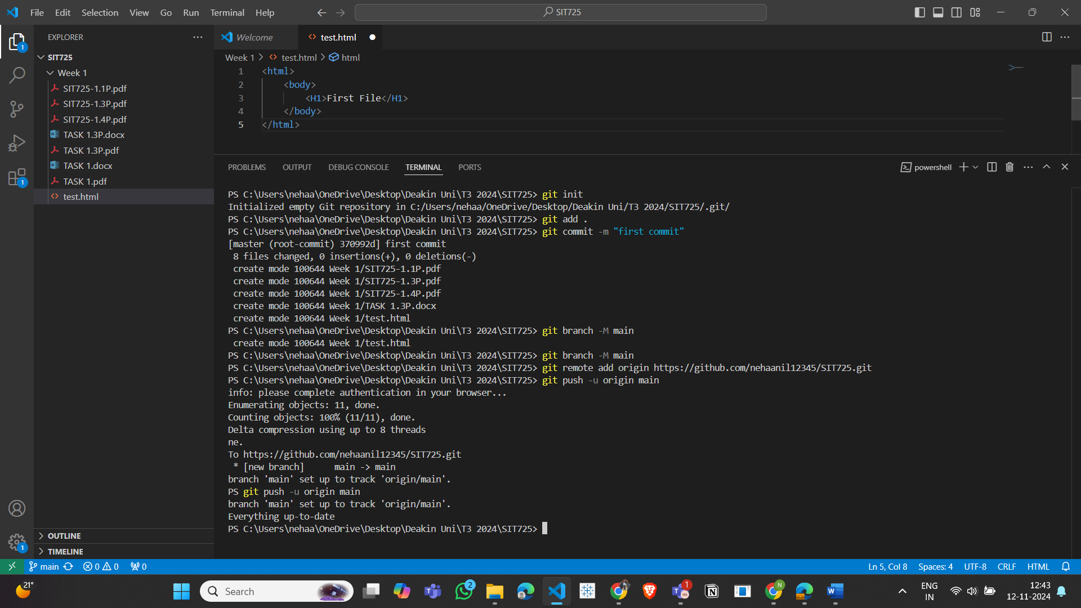

Git hub link to my repository:

<https://github.com/nehaanil12345/SIT725.git>